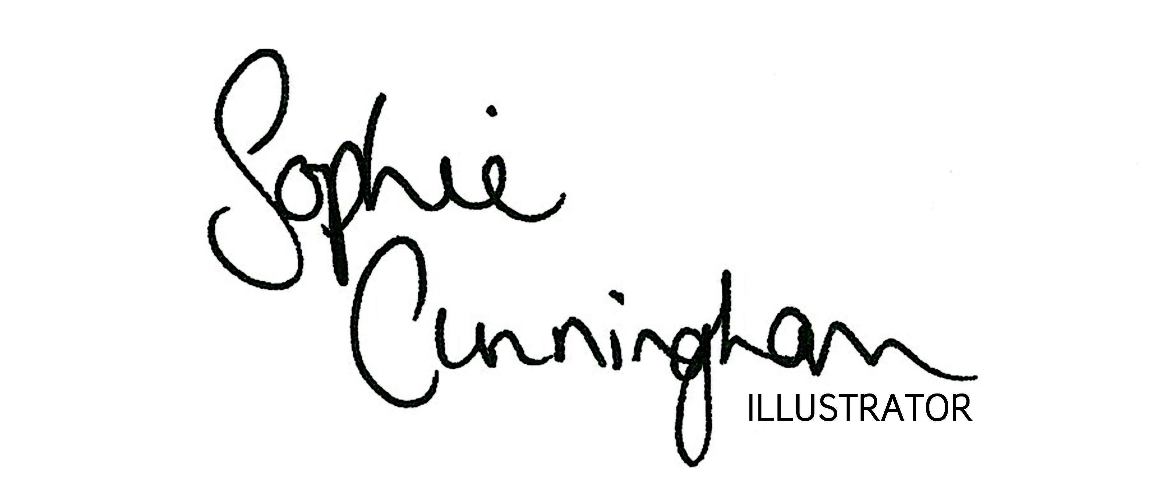
INVOICE

Invoice number
Date

Sophie Cunningham Illustrator. 3 Lee View Court, Todmorden. OL14 5LJ
sophie_cunningham@hotmail.co.uk
07958432263
www.sophiecunninghamillustrator.co.uk

Company Name:

Company Address:

Tel: Email:

Code | Description | Qty | Unit Price | Total
Total
Delivery 2 – 3 weeks from date of order. Invoice to be paid BEFORE goods will be shipped
BACS: Sort Code 09-01-26 . Account Number, 69950372.
Paypal also accepted to: sophie_cunningham@hotmail.co.uk
Please quote the invoice number above

